HOT-TIA Referral System Instructions Manual
The HOT-TIA referral system is an IT form that enables rapid referral for stroke and transient ischaemic attack patients to local stroke units.
In order to use the HOT-TIA quick referral system please follow the link: https://referrals.southend.nhs.uk/HOTReferrals/ please also save this link to your favourites or to your desktop for ease of access.
Once you have opened up the system you will be presented with a front page similar to the one detailed below.
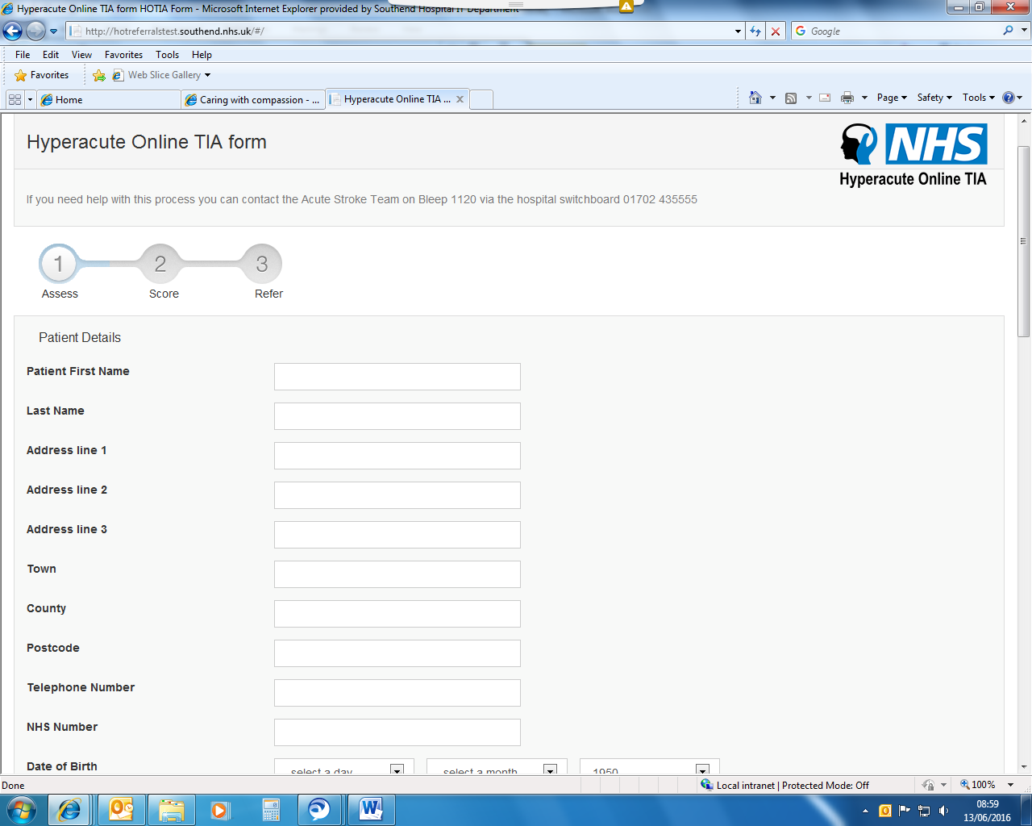
Please complete each line using the details relevant to the patient being referred into the stroke service.

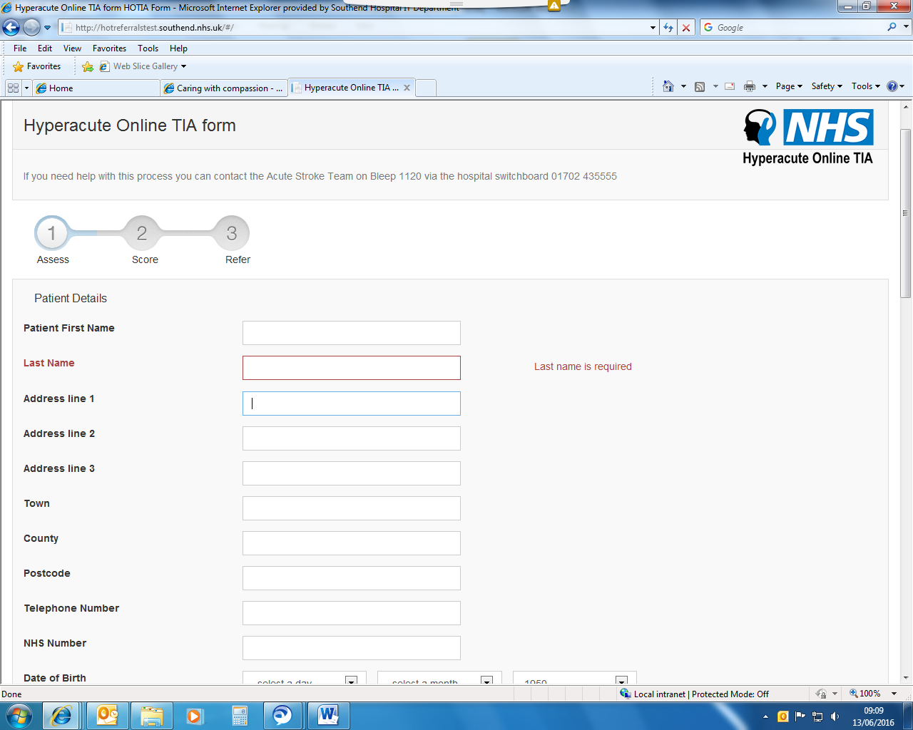
You will be given this prompt if a mandatory field is left blank. Please fill out the form carefully and check all the details entered.
Once the patients’ basic details have been collected it is important for the Hospital to collect some basic details from the referrer.
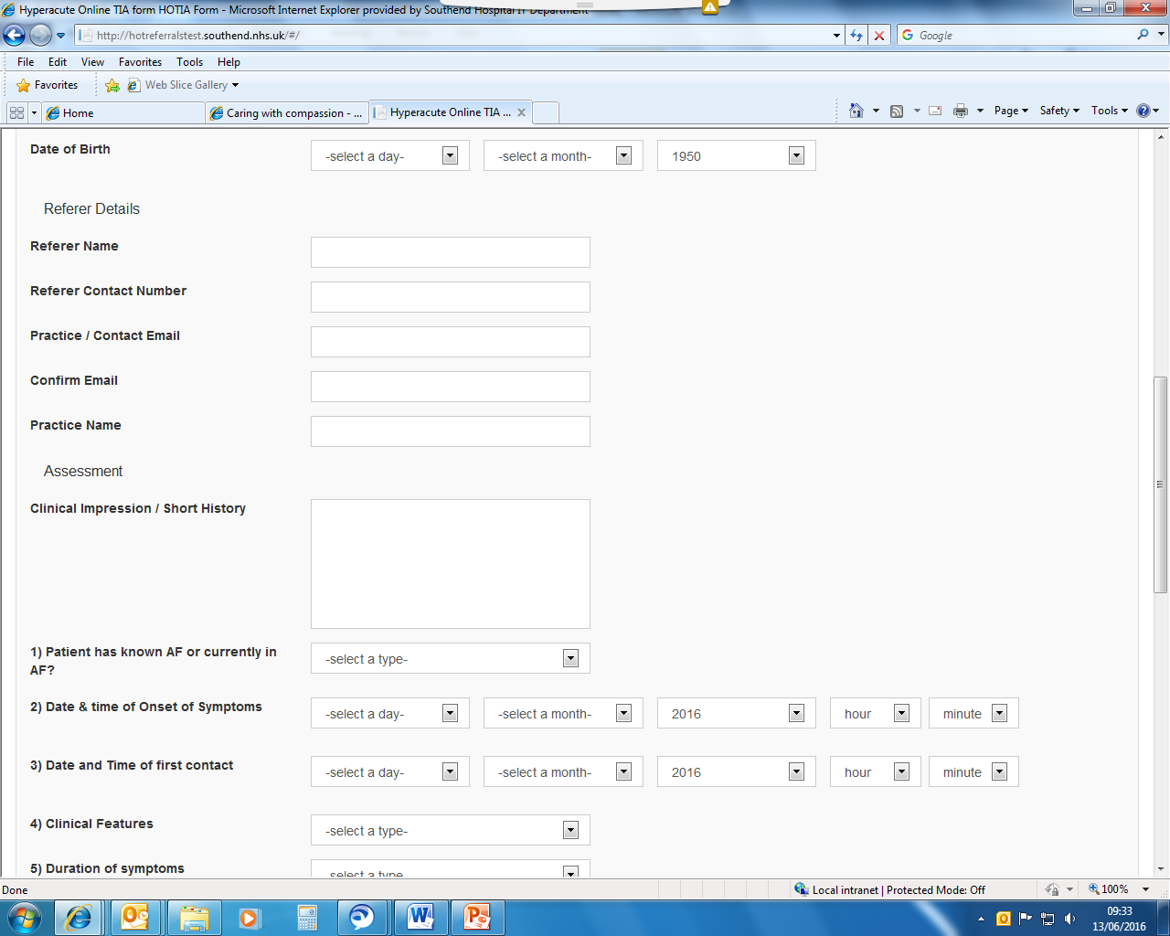
Please complete these fields with your own details. This ensures that the hospital can respond to the referrer if necessary.

The patient’s assessment details now need to be completed. It is important that the assessment details are completed as accurately as possible in order to ensure the correct assessment is obtained.
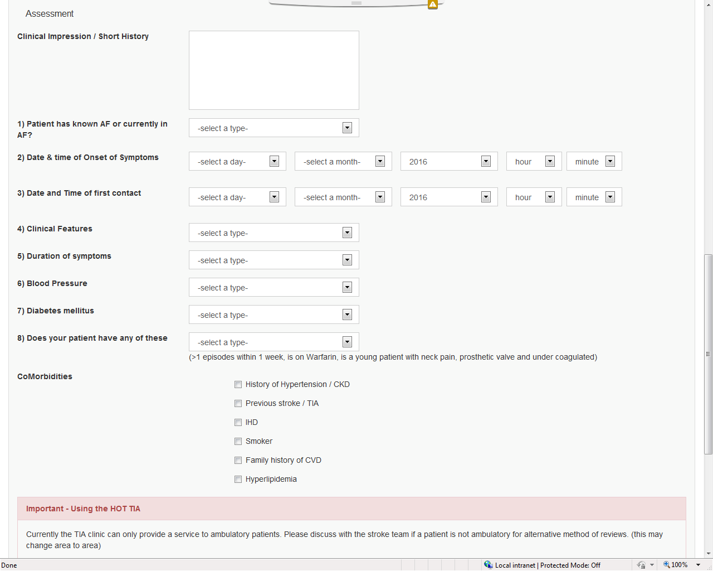
A mix of drop downs and tick boxes can be used to complete the patient assessment information.
Once the form is complete please review all the information you have input and read the disclaimer below.
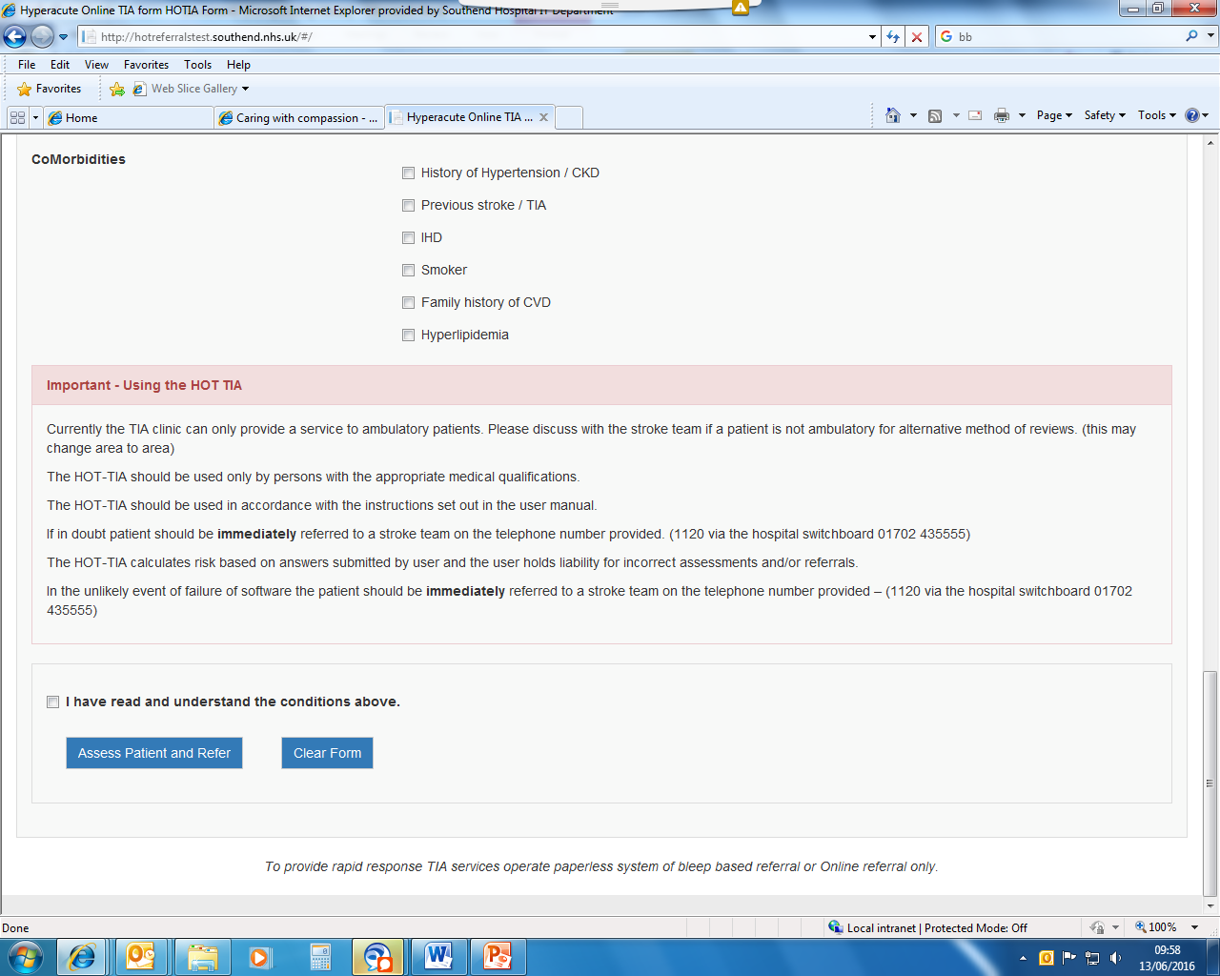
Once you are happy with the information submitted please tick the box and click assess patient and refer. If you wish to start again you can use the clear form button.

Once you have completed the front sheet you will be given your assessment and the opportunity to refer the patient to the hospitals available in your area.
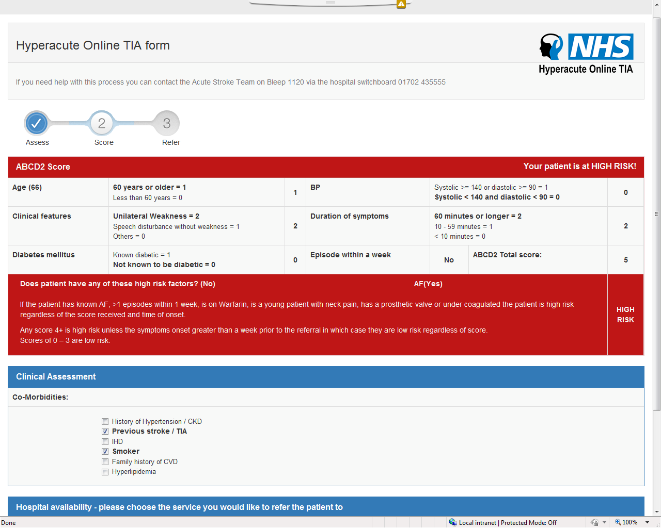

In order to complete your referral please select your region from the drop down box as highlighted below.
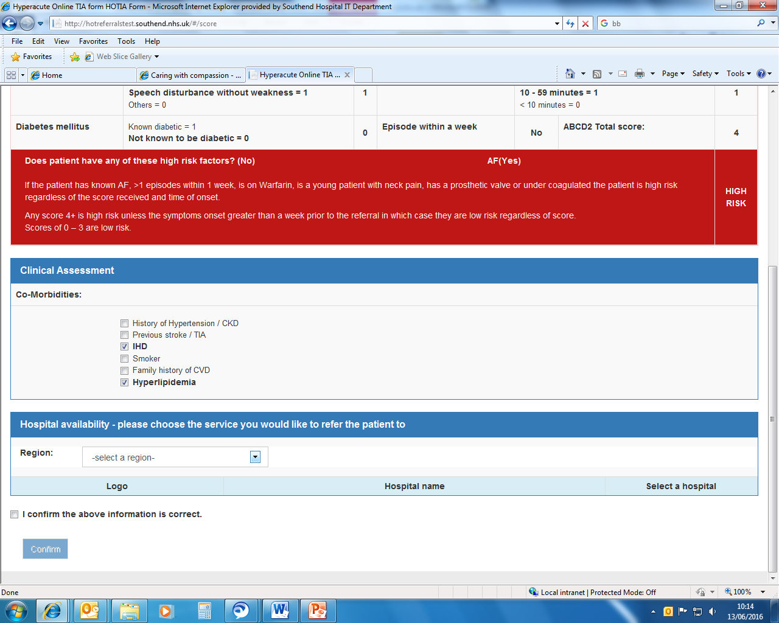
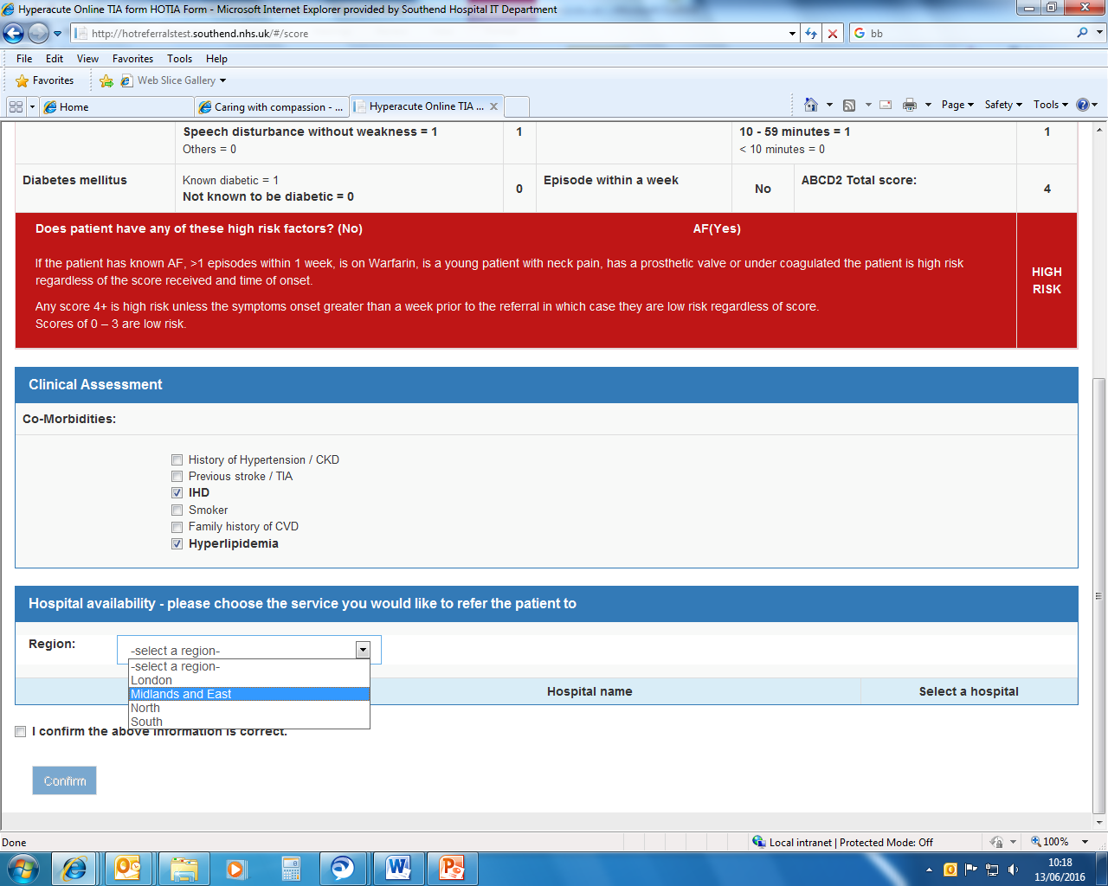

You will now be able to select a hospital and complete your referral.
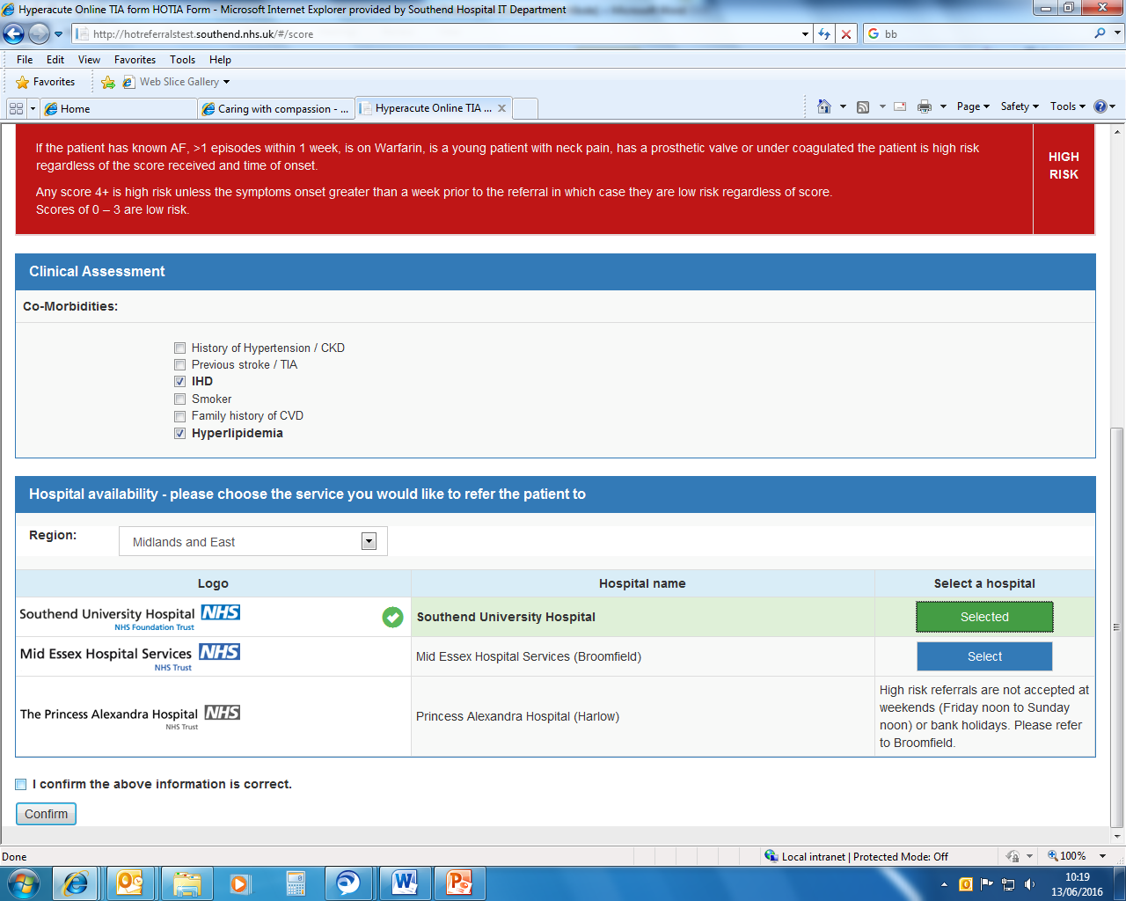
When you have selected a hospital please check the information one final time and tick the box and click confirm to complete your referral.

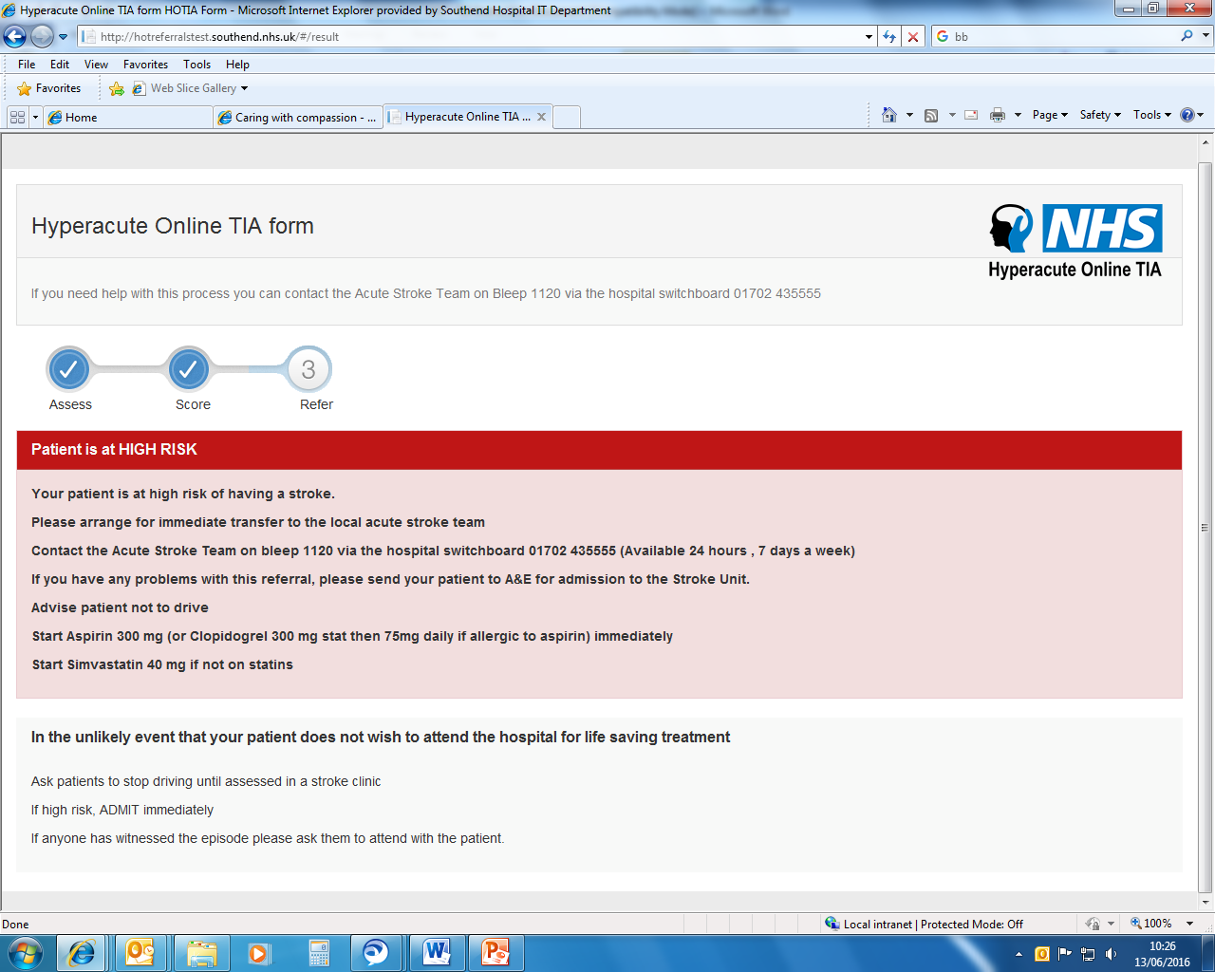
The final page will give you instructions on how to proceed with your patient based on the information you have provided. For any further information please contact your local stroke unit.
Please check that you receive confirmation of your referral to the email address provided
Please also ensure that you follow all instructions given and ensure you follow the ‘What to do next’ form for all patients whether they are high or low risk.

